
ResBaz Queensland
St Leo’s College Accommodation
Please:
- Complete and save the form paying particular attention to arrival dates and times, and dietaries.
- Email it to: stay@stleos.uq.edu.au
You will be emailed a confirmation of room booking within 3 business days.

College Information:
St Leo’s provides college accommodation for students during the university semesters. During the non-semester periods our college welcomes bookings from visiting groups who need to be aware that bedrooms are set up for single occupancy students, and do not provide hotel-style facilities like room service, daily refreshing of bedrooms, twin-share etc.
All rates quoted below include 3 meals per day commencing with lunch on arrival day and concluding with breakfast on departure day. We do not provide any other rates (eg bed with no meals or B&B), and no discounts are given for meals not taken.
Meals are served at the following times:
Breakfast: 7-9am
Lunch: 12-1pm
Dinner: 5-6pm
Free guest wifi is available throughout the College. There is ample free on-site parking.
All bedrooms must be vacated by 10am on departure date.
Payment is to be made prior to arrival – on line is preferred. You will be provided with an invoice at time of booking confirmation.

Facility Details:
All rooms are single, separate, electronically locked, air conditioned, and contain a small fridge. Bed and bath linen are provided. Guests need to supply all of their own toiletries.

Standard: Single separate room (long single bed).
Shares bathrooms with 7 other guests in a block of 8 bedrooms (1 gender per block).
Rate: $90.00 per room per night.

Shared ensuite: Single separate room, double bed.
Shares a bathroom with 1 person – bathroom is located between the 2 bedrooms.
Placement will be either 2 males or 2 females unless specifically requested.
Rate: $110.00 per room per night. Each room is individually booked.

Ensuite: Room with private bathroom, 1 double bed – this cannot be exchanged for twin-share.
Suitable for 1 or 2 people who will share a double bed.
Rate: $130.00 per room per night (1 person); $170.00 (2 people).
Please note: Family rooms are not available, and our facilities are not suitable for small children.
Room: ____________
Charge:
Inv No: ____________

ResBaz Queensland
Accommodation Reservation Form
Dates required: Arrival date: Departure date:
Approximate time of arrival:

First Name: |  |  | Family Name:
Contact mob.: |  |  | Email:
Gender: | Male Female | Have you stayed at Leo’s previously Yes No
Car make (if bringing vehicle on site): Car Rego
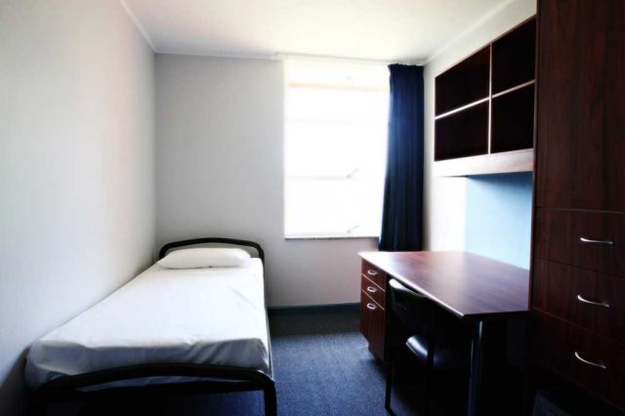
Room Type
Standard with shared bathroom facilities ($90 per night)
(8 rooms in a block sharing 2 showers & 2 toilets)
1 x Shared Ensuited room – single ($110 per room/per night)
(2 single separate rooms share one bathroom)
Standard room
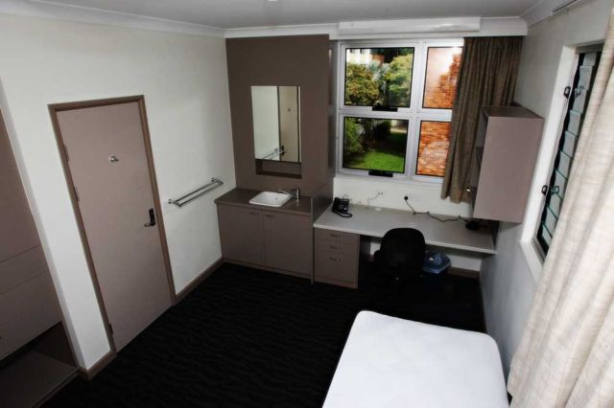
Ensuited room – 1 person ($130 per night) – private bathroom
Ensuited room – 2 people ($170 per night) – private bathroom
(One double bed only - cannot be replaced with two single beds)
- Rates include 3 meals per day within stated check-in / checkout dates.
- No credits or discounts if meals not taken.
Shared ensuited room
- Early and late arrivals are possible (please advise arrival time).
- All bathroom and bed linen included.
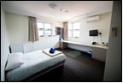
- Guests need to supply own toiletries.

Payment:
I will pay my own accommodation. If my accommodation is being paid by another party, invoice details are here:
Ensuited room
For arrivals after 5.00pm - late meal required on arrival: YES / NO
Dinner service concludes at 6.00pm during holiday periods.
Special dietary requirements:
If you have any allergies, or specific dietary requirements, please note this below as we are providing you with 3 meals per day and our chefs need to be aware in advance of your arrival.
Vegetarian, dairy free and Halal are included in the rates, however we do need to know in advance.
A charge of up to $3 per meal will be levied on those requiring more specialised diets such as vegan, nut, gluten or lactose free.

If no entry is made below, we are assuming you do not have any specific dietary requirements.
Dietaries required:
Further detail regarding my booking: (including placement with another party):

